Exp. No: 11
Verification of Maxwell’s Equations and Displacement Current in Time-Varying Electromagnetic Fields
Test Case (i) – Displacement Current in a Parallel-Plate Capacitor
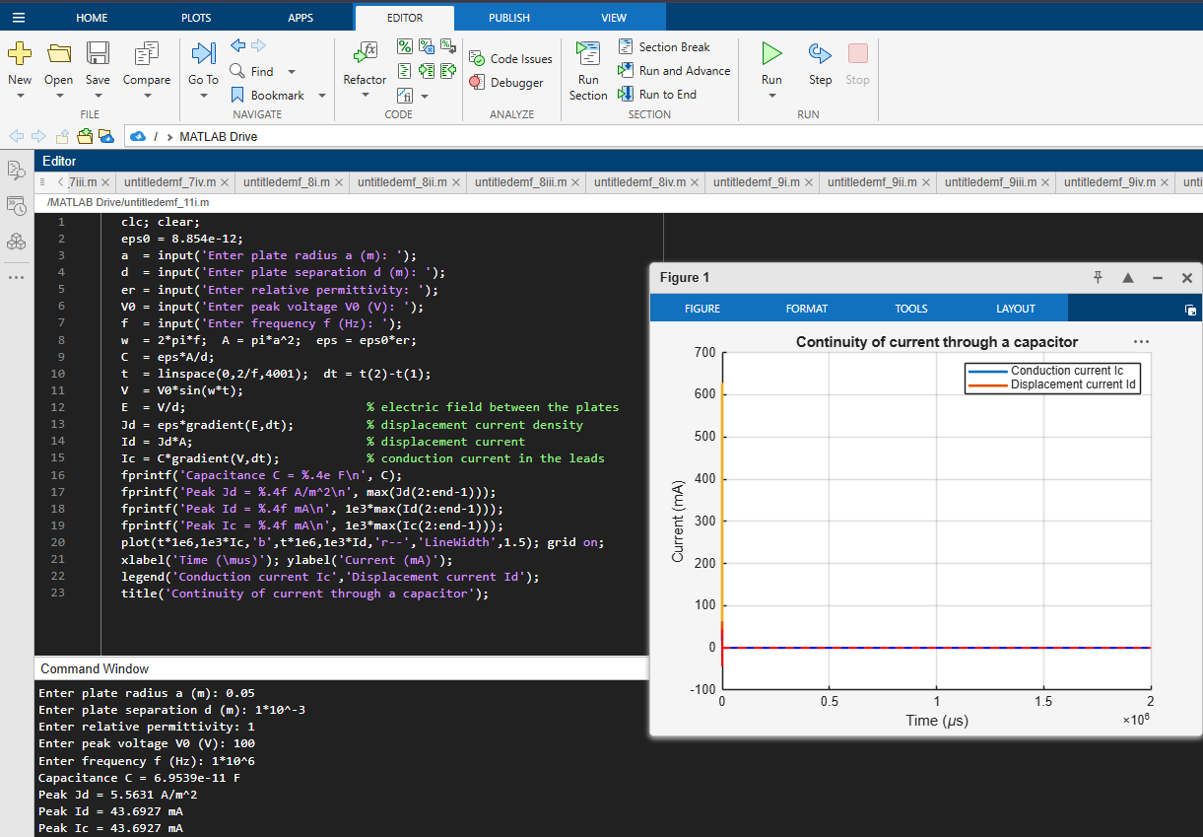
Test Case (ii) – Conduction and Displacement Current in Different Media
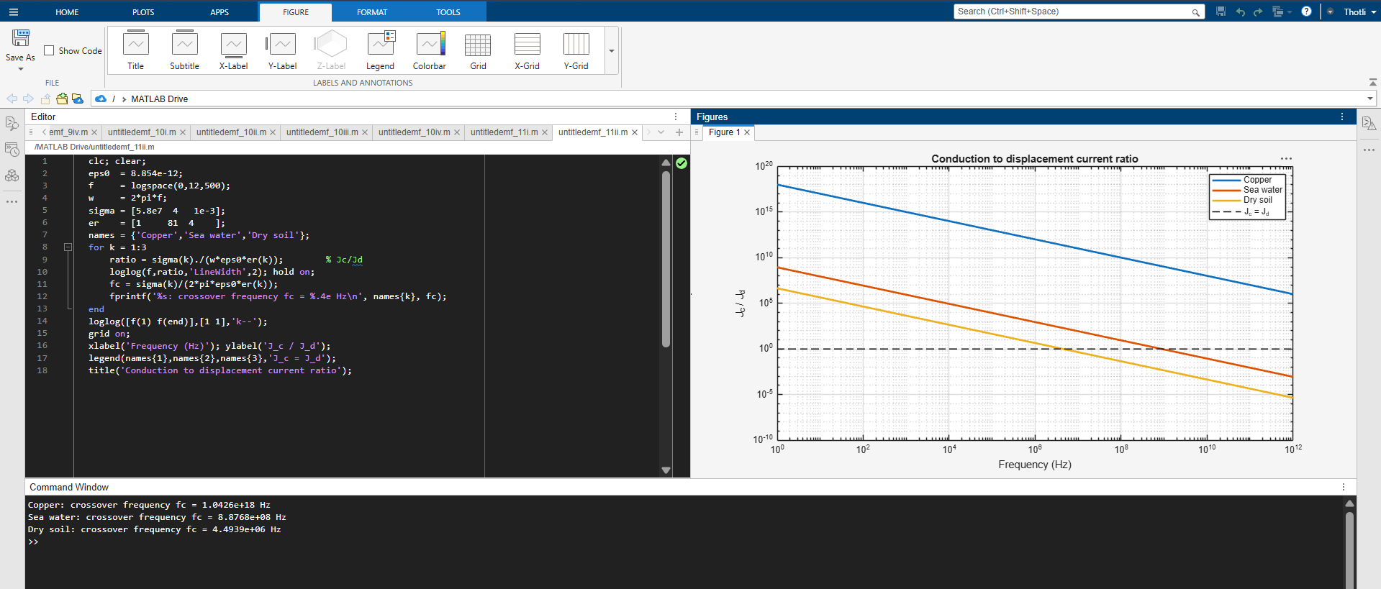
Test Case (iii) – Numerical Verification of Maxwell’s Curl Equations for a Plane Wave
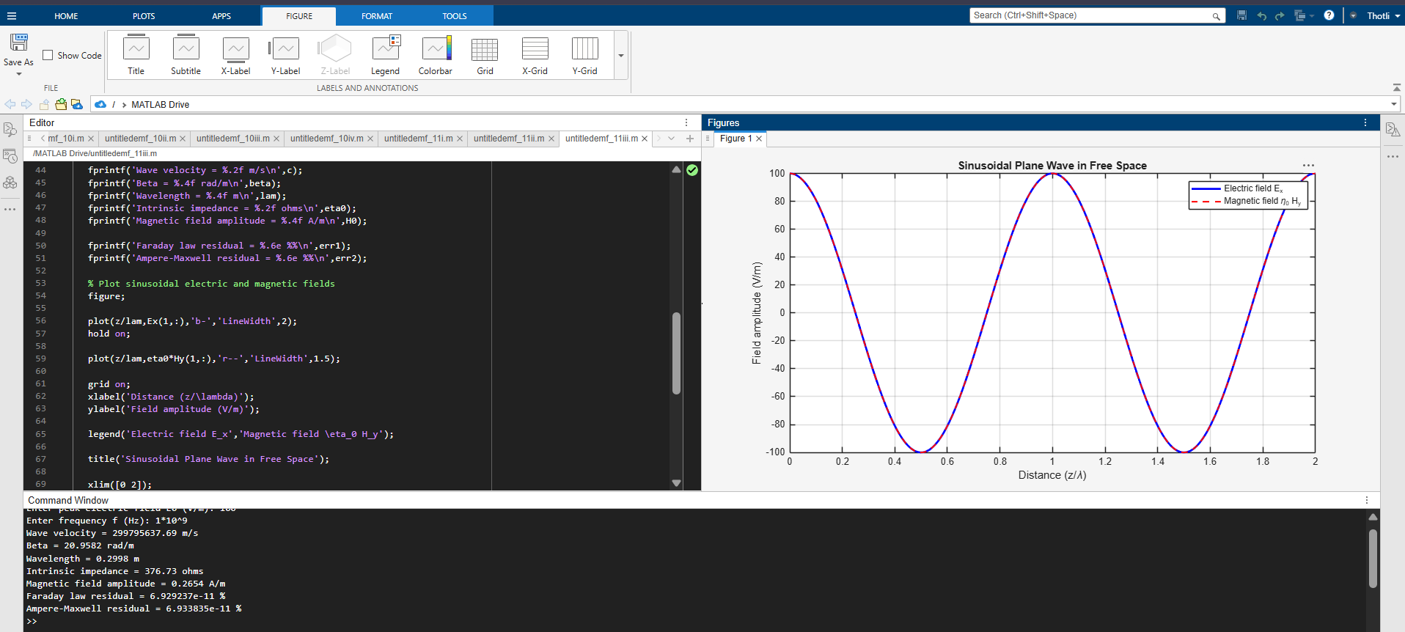
Test Case (iv) – Magnetic Field Produced by Displacement Current (Ampère Maxwell Law)


